Online Robustness Appendix to
“Endogenous Gentrification and Housing Price Dynamics”

Veronica Guerrieri
University of Chicago and NBER

Daniel Hartley
Federal Reserve Bank of Cleveland

Erik Hurst
University of Chicago and NBER

July 2010

Robustness Appendix to “Endogenous Gentrification and Housing Price Dynamics”

This robustness appendix provides a variety of additional results and background material for our paper “Endogenous Gentrification and Housing Price Dynamics”. All data and code for this paper can be found at http://faculty.chicagobooth.edu/erik.hurst/research/. As noted in the main paper, we are contractually prevented from posting the Case-Shiller data. However, we posted all other data online. Additionally, we have posted all the relevant code used to make the tables and figures reported both in the main paper and in the robustness appendix.
This appendix is broken into four sections. In the first section, we review the different price indices we use within the paper and this appendix and then we discuss the correlation between the various price indices. In the second section, we redo the main analysis from the paper using the Zillow price indices. In the paper, we presented our main empirical results using the Case-Shiller price indices. As seen from the results below, all of our main results go through using the Zillow price indices. Moreover, there are less selection issues within the Zillow data. As a result, the Zillow data allow us to be confident that the patterns we document for the Case-Shiller data are found in all zip codes within the city not only the zip codes for which Case-Shiller computes a price index series. In the third section, we present much greater detail on within-city house price movements for many different cities during many different time periods. The figures in this section are akin to Table 3 of the main text. In the final section, we show many of the other robustness specifications discussed in the text. For example, we show the results of Table 4 controlling for age of structure fixed effects.

1. Correlation Across Different Price Indices
In the main paper, our primary empirical results focused on within-city house price movements using data from either the Case-Shiller zip code level price index (Tables 3, 4, 5, 6 and 7) or Chicago Tribune indices that we compiled ourselves (Figure 1 and Table 1). In this section and in the next section, we explore the robustness of our results to using alternate within-city house price measures. In this section, we discuss the correlation between the various within-city price indices. In the next section, we redo the main empirical results from our paper using other house price series. The main take away from this section is that the various within-city house price measures to which we have access are highly correlated with each other. The main take away from the next section of the paper is that the key empirical regularities shown in the paper using the Case-Shiller data or the Chicago Tribune data go through when we use price indices created by Zillow or house price measures from the U.S. Census.
Before showing the correlation across the different house price indices, it is useful to discuss the Zillow data in much greater depth. See the main text for detailed discussions about the Case-Shiller and Chicago Tribune housing price indices.
A. The Zillow Zip Code Level House Price Indices
In the following section, we examine the robustness of our results by redoing, when possible, our main analyses using zip code level house price indices created by Zillow. The Zillow zip code level indices only go back in time through the late 1990s and were provided to us at the monthly level. There are some similarities between the Zillow and Case-Shiller indices. In terms of similarities, both Zillow and Case-Shiller use the publically available deed data as the underlying source of house price information used to compute their indices. An additional similarity is that the Zillow data tags some of the price indices within certain zip codes as being less reliable than others because of the fact there were not enough underlying transactions within the zip code to compute a reliable index. As with the CS data, we only use the zip codes that were not tagged by Zillow as being potentially unreliable with respect to their house price measure.
The Zillow and CS indices do differ in two ways. First, Zillow does not use a repeat sales methodology to create their housing price indices. Instead, Zillow uses the same underlying deed data as the Case-Shiller index, but creates a hedonically adjusted price index. The exact methodology of the hedonic adjustment is not publically available (i.e, the hedonic adjustment is proprietary information). To do the hedonic adjustment, Zillow merges in data from public records about individual housing characteristics including data from local tax assessors and MLS listings. Additionally, they allow home owners to update their housing characteristics directly through the Zillow web site. Without giving away their hedonic formula, Zillow’s web page states that they use information on the size of the house, the number of bedrooms, and the number of bathrooms – along with other information – in their hedonic adjustments. To the extent that Zillow can measure the average characteristics of the home changing over time, the Zillow index will be able to adjust for those changes. This feature is an improvement over the Case-Shiller methodology which assumes that structure attributes remain fixed over time.
The second way that the Zillow index differs from the CS index is through its time coverage. The Zillow data only extends back through the late 1990s. As a result, we are only able to directly compare the Zillow results with the CS results for the 2000-2006 period that we analyze.
B. The Correlation Across The Different Price Indices
In Table R1, we show the correlation across the different house price measures that we used. The table is divided into two panels. The top panel examines the correlation across the three house price series that we have for Chicago. Again, given that the Chicago Tribune index and the Zillow index are only available starting in the late 1990s, we focus our attention on house price growth between 2000 and 2006. Also, as discussed above, we do not have reliable Case-Shiller indices and Zillow indices for all zip codes within Chicago. There are 54 zip codes completely contained within Chicago. For 49 of these zip codes, we have a Chicago Tribune index. We only have a reliable Case-Shiller index for 26 of the zip codes within Chicago. However, we do have a reliable Zillow index for 47 of the Chicago zip codes. As seen from the table, there is a strong correlation in house price growth at the zip code level within Chicago across all the different price indices. In particular, the correlations across all the potential price index pairs hovers around 0.75.
In the bottom panel of Table R1, we explore the correlation between the Zillow and the Case-Shiller zip code level price indices across all cities (including Chicago). There are 3,223 zip codes for which we have both a Zillow and Case-Shiller index. These zip codes comprise both the main MSA city and the suburbs. We also focus on the correlation between the two indices restricted to only the main city within each MSA. We have 483 zip codes which are in the main MSA city for which we have both Case-Shiller and Zillow zip codes. In both the broader sample of zip codes across all MSAs and all main cities where we have both indices, the correlation in the growth in housing prices between the Case-Shiller and Zillow indices was around 0.9. This correlation foreshadows the results show in the next section: our main results from the paper are robust to whether or not we use the Case-Shiller index or the Zillow index.

2. Redoing Tables 3 and 4 With Zillow Data
Two key results from our main paper are: 1) neighborhoods within a city with lower price properties appreciate, on average, at much higher rates than neighborhoods within a city with higher price properties during city wide property price booms and 2) among lower price neighborhoods within a city, it is the lower price neighborhoods that are closest to the higher price neighborhoods that appreciate the most during city wide housing price booms.
In this section, we re-examine both of these findings using the Zillow house price indices as opposed to the Case-Shiller house price indices. There are two reasons we may be concerned about using the data from Case-Shiller for our main results. First, the coverage within a city is lower for Case-Shiller than for Zillow (see the discussion of Chicago above). In particular, Case-Shiller – given its repeat sales methodology – uses less underlying observations than Zillow. The result of this is that Zillow computes “reliable” (from their perspective) price indices for more of the zip codes than does Case-Shiller. By using the Zillow data, we can see whether the incomplete coverage of the zip codes by Case-Shiller is in any way biasing our results. Second, the Case-Shiller index only, at best, partially controls for changes in the housing structure over time. The Zillow index, given its hedonic approach, can adjust for the changes in structure characteristics over time, to the extent that the changes are measured. Again, using the data from Zillow allows us to examine whether the Case-Shiller index could be yielding biased results.
In Table R2, we replicate Table 3 from the main text using Zillow data as opposed to Case-Shiller data. As discussed above, we could only examine the results for the 2000-2006 period using the Zillow data because the Zillow index does not exist prior to the late 1990s. In Table R2, we show two panels. In the top panel, we restrict our analysis to the same underlying samples as in Table 3 from the main text. This means we only look at those zip codes within the MSA where a Case-Shiller house price index exists. In the bottom panel of Table R2, we show the data for all zip codes within the city/MSA for which we have a reliable Zillow index.
Table R2 is set up analogously to Table 3. In the first column, we report the average house price growth between 2000 and 2006 for neighborhoods in the top quartile of the house price distribution in 2000 (quartile 1). These are the high price neighborhoods. The fourth column reports the average house price growth between 2000 and 2006 for neighborhoods in the bottom quartile of the house price distribution in 2000 (quartile 4). Columns 2 and 3 show the results for neighborhoods in the second and third quartiles, respectively. As seen from the table, the Zillow data provides similar results to the Case-Shiller data (shown in Table 3 of the main text). Across all cities or MSAs, properties in low priced neighborhoods (in quartile 4) appreciated at much higher rates than properties in high priced neighborhoods. This suggests that the results documented in Table 3 of the main text are not limited to just the Case-Shiller data which only, at best, controls for changes in structure quality. Additionally, given that the results are similar between the top and bottom panels, it is not the case that the selection of the zip codes where Case-Shiller can compute a reliable index is biasing our results in any way.
In Table R3, we redo the analysis from Table 4 of the main paper using Zillow data. Again, we can only do this for the 2000-2006 period. This table shows the results from a regression of the following specification:
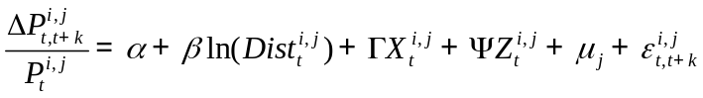
where all the variables are defined in the text. As in the paper, we restrict our sample to include: 1) only those zip codes from the center city within the MSA (i.e., exclude the suburbs) and 2) only those zip codes within a city that were from the bottom half of the house price distribution in year 2000. This latter restriction is made to restrict our attention to poorer neighborhoods, as our theory predicts.
In column 1 of Table R3, we re-report the results of the above regression using the Case-Shiller data. This regression is the same as the one reported in column 2 of Table 4 from the main text. We re-report the regression for comparison purposes. This regression includes the full vector of X and Z controls. The key coefficient of interest is β – the coefficient on the log distance to rich neighborhoods (neighborhoods in the top quartile of the initial house price distribution). Using the Case-Shiller data, we find that a doubling of the distance to rich neighborhoods reduces the house price appreciation by roughly five percent. In column 2, we redo the estimation in column 1, but restrict the sample to include only those zip codes for which a Case-Shiller and a Zillow index exist. As in column 1, we use Case-Shiller data for our house price measures. Restricting the sample in this manner causes the coefficient on log distance to rich neighborhoods to decrease slightly. We do this so we can compare the results using the Case-Shiller indices and the Zillow indices more directly.
In columns 3 and 4, we show the results of this specification using the Zillow data. In column 3, we use the same sample as in column 2 but instead of using the Case-Shiller price index we estimate the above equation using the Zillow price index. Using the Zillow data does not change the magnitude of the coefficient on log distance to nearest rich neighborhood. Finally, the magnitude of the coefficient on log distance to the nearest rich neighborhood increases slightly in column 4 (where we use all of the Zillow data). This implies that the effect that we are measuring may be stronger in some of the zip codes which have a low number of single family homes which Zillow covers but, Case-Shiller does not.
We find the results shown in Table R2 and R3 very reassuring. We understand that the Case-Shiller index has potential limitations. Re-estimating our main results using the Zillow data, which has more extensive coverage and attempts to better control for changes to the housing structure, yields very similar estimates of proximity to rich neighborhoods on housing price dynamics. The key facts we document in the paper are robust to either the Case-Shiller index or the Zillow index.

3. More Detailed Information on Within-city/MSA Housing Price Dynamics
In this section, we show much more information on within-city house price dynamics during the 1990s and during the 2000s. Summaries of this information are shown in Table 3 of the main paper. While we find much of this very interesting, we found it more tangential to the main points we were trying to drive home in the paper.
Figure R1 shows the relationship between initial house price and subsequent housing price growth between 2000 and 2006 for Chicago at the zip code level using data from the Case-Shiller, Chicago Tribune, and Zillow Indices. These figures show the underlying data that is summarized more coarsely in Table 3 of the main text.
Figure R2 shows the relationship between initial house prices and subsequent house price growth for many other cities/MSAs for many different time periods using the Case-Shiller data. These figures show more of the underlying data that is summarized in Table 3 of the main text.
Figure R3 shows the relationship between initial house prices and subsequent house price growth for many other cities/MSAs for the 2000-2006 period using the Zillow data. These figures show more of the underlying data that is summarized in Table R2 of this robustness appendix.
Figure R4 shows the relationship between initial house prices and subsequent house price growth for New York City during different time periods using the Furman data. The Furman data is a repeat sales index computed by the Furman Center for Real Estate and Urban Policy at New York University and is discussed in more detail in the main text.
Figures R5a and R5b show new results. In Figure 5a, we plot the MSA level house price appreciation rate between 2000 and 2006 on the x-axis (using FHFA data) against the estimated coefficient on initial house price level from the within MSA regression of zip code level house price growth between 2000 and 2006 on the log of the median house price in the zip code in 2000 (on the y-axis). Basically, this coefficient measures the within-MSA difference in house price appreciation rates between high housing price neighborhoods and low housing price neighborhoods. The more negative is this coefficient, the more that lower house price neighborhoods appreciated relative to higher house price neighborhoods. For this figure, we only show the results of computing the within city housing price growth-initial housing price level elasticity using Case-Shiller data. Each observation in this figure is an MSA. One empirical result that we thought interesting to highlight is that in cities that experienced larger housing price booms, poorer neighborhoods – on average – appreciated at much higher rates than richer neighborhoods – on average. This result is broadly consistent with the predictions of our model.
Figure 5b shows the same type of results but for the 1990-1997 period. As seen in this figure, the relationship between the average size of the MSA-wide house price appreciation and the within-MSA difference between rich and poor neighborhood appreciation is not limited to the recent period. During the 1990s, MSAs with large housing price booms also had within MSA-housing price dynamics such that poorer neighborhoods had housing prices that appreciated at much higher rates than richer neighborhoods.
Again, while we find these results very interesting, they are not the main results on which our conclusions are based. However, we think it is a fruitful area of future research to explore the general patterns of within-city/MSA house price dynamics in much greater detail.

4. Additional Robustness Specifications
In this section, we discuss the results for a few additional robustness specifications.

A. Adding Age of Structure Controls to Table 4 of Main Text
Table R4 re-estimates the first two columns of table R3 adding controls for the distribution of the age of residential buildings in the zip code. Variables indicating the fraction of buildings built in the past 0 to 5 years, 6 to 20 years, 21 to 40 years, and 41 to 60 years are included. The fraction built more than 61 years ago is excluded. Adding these controls does not change the magnitude of the coefficient on log distance to nearest rich neighborhood. These results suggest that our main results in the paper are robust to the stories of gentrification put forth by Brueckner and Rosenthal (2009).
B. Expanding the Results in Table 5 of Main Text to Include the Suburbs
Most of our main empirical work was done only looking in large cities (the primary city within the MSA). We have done a bunch of robustness specifications to show that our broad patterns also hold within the suburbs. We do not show the suburbs as our primary results because we are worried about sorting that could occur across different geographical locations. However, in Table R5 we redo the main empirical results show in Table 5 of the main paper but include all zip codes within the MSA into our sample. See the text for details about the specification and sample of Table 5. The only difference in Table R5 is the addition of the suburban zip codes into our analysis. Notice, when we include the suburbs into our analysis, the results remained unchanged. Zip codes which experienced large increases in median income, zip codes that experienced large declines in the poverty rate, and zip codes that experienced a larger percentage decline in resident tenure all experienced large house price appreciations. These results hold regardless of whether or not suburban zip codes are included.
C. Re-Estimating Table 1 From Main Text With Zip Code and Census Data
In Table R6 we re-estimate column 4 of Table 1 from the paper. However, Instead of using the Chicago Tribune index for Chicago community areas, we recalculate the Chicago Tribune Index for zip codes and also use home values from the 2000 Census at the zip code and census tract levels. Column 1 shows that the relationship between income and housing prices is still statistically significant although the magnitude of the coefficient is smaller when we recalculate the Chicago Tribune index at the zip code level rather than the community area level. Column 2 is also at the zip code level of geography, but uses median home values reported in the 2000 Census rather than the Chicago Tribune index as the dependent variable. Column 3 uses the same dependent variable but conducts the analysis at the finer census tract level of geography. The coefficients on income in columns 2 and 3 of Table R6 are quite similar to the coefficient on income in column 4 of Table 1 from the paper, implying that the relationship between income and housing prices when controlling for commuting time, distance to amenities, and racial composition is relatively stable across different geographic divisions and different housing price definitions for the city of Chicago.

Table R1: Correlation Between Various Housing Price Indices

House Price Index Measure/Time Period | Correlation
Housing Price Growth, Within Chicago Across Zip Codes (2000-2006)
Chicago Tribune Index vs. Zillow Index (All Chicago Zip Codes, # observations = 47) | 0.69
Chicago Tribune Index vs. Zillow Index (Only Case-Shiller Zip Codes, # observations = 25) | 0.81
Chicago Tribune Index vs. Case-Shiller Index (Only Case-Shiller Zip Codes, # observations = 26) | 0.71
Case-Shiller Index vs. Zillow Index (Only Case-Shiller Zip Codes, # observations = 25) | 0.82
Housing Price Growth, Within All Case-Shiller Cities Across Zip Codes (2000-2006)
Case-Shiller Index vs. Zillow Index (Only Case-Shiller Zip Codes, # observations = 3,404) | 0.94
Case-Shiller Index vs. Zillow Index (Only Zip Codes Within the Main City of the MSA, # observations = 471) | 0.95

Note: This table shows the correlation in house price growth between 2000 and 2006 for the different measures of house price indices that we use throughout the paper.
Table R2: Re-Doing Table 3 From Main Paper With Zillow House Price Index As Opposed to Case-Shiller House Price Index

City/MSA/Time Period | Quartile 1 | Quartile 2 | Quartile 3 | Quartile 4 | p-value of Quartile 4 = Quartile 1
Only Case-Shiller Zip Codes
New York City, MSA Level, 2000-2006 | 0.59 | 0.73 | 0.76 | 1.10 | 0.00
Boston, MSA Level, 2000-2006 | 0.34 | 0.45 | 0.52 | 0.63 | 0.00
Los Angeles, MSA Level, 2000-2006 | 0.86 | 1.14 | 1.41 | 1.67 | 0.00
San Francisco, MSA Level, 2000-2006 | 0.26 | 0.29 | 0.44 | 0.60 | 0.00
Washington D.C., MSA Level, 2000-2006 | 1.10 | 1.24 | 1.19 | 1.23 | 0.22
All Zip Codes
New York City, MSA Level, 2000-2006 | 0.54 | 0.68 | 0.72 | 0.94 | 0.00
Boston, MSA Level, 2000-2006 | 0.31 | 0.42 | 0.53 | 0.65 | 0.00
Los Angeles, MSA Level, 2000-2006 | 0.87 | 1.13 | 1.42 | 1.67 | 0.00
San Francisco, MSA Level, 2000-2006 | 0.23 | 0.26 | 0.37 | 0.54 | 0.00
Washington D.C., MSA Level, 2000-2006 | 0.91 | 1.05 | 1.13 | 1.32 | 0.00
New York City, City Level, 2000-2006 | 0.46 | 0.69 | 0.76 | 0.82 | 0.00
Boston, City Level, 2000-2006 | 0.27 | 0.42 | 0.48 | 0.69 | 0.00
Los Angeles, City Level, 2000-2006 | 0.92 | 1.13 | 1.53 | 1.75 | 0.00
San Francisco, City Level, 2000-2006 | 0.21 | 0.19 | 0.34 | 0.55 | 0.01
Washington D.C., City Level, 2000-2006 | 0.83 | 1.43 | 1.53 | 1.64 | 0.00
Notes: This table shows the house price appreciation between 2000 and 2006 for different zip codes within the 2000 house price distribution. Quartile 1 (Quartile 4) shows the average house price appreciation for zip codes that were in the top (bottom) quartile of housing prices in year 2000. The table is analogous to Table 3 of the main text except that it uses Zillow data to compute the housing price appreciations. The top panel uses only those zip codes for which Case-Shiller has a house price index based on actual transaction data. The bottom panel uses all zip codes for which a Zillow index is available.
Table R3: Re-Doing Column 2 of Table 4 of Main Table With Zillow Price Index

 | Using Case-Shiller Data on Zip Codes for Which a Case-Shiller Index Exists | Using Case-Shiller Data on Zip Codes for Which Both a Case-Shiller and Zillow Index Exists | Using Zillow Data on Zip Codes for Which Both a Case-Shiller and Zillow Index Exists | Using Zillow Data on Zip Codes for Which a Zillow Index Exists
Log Dist to Nearest High Price Neigh. | -0.05 | -0.06 | -0.05 | -0.06
 | (0.02) | (0.02) | (0.03) | (0.03)
Other Control Variables Included? | Yes | Yes | Yes | Yes
Observations | 225 | 200 | 200 | 262

Notes: This table is analogous to the specification in column 2 of Table 4 of the main text. Column 1 of this table just re-displays the results from column 2 of Table 4 of the main paper. Column 2 of this table re-estimates column 1 but for only the zip codes where both a Case-Shiller and Zillow index exists. Column 3 of this table re-estimates column 2 but uses Zillow price indices instead. Column 4 re-estimates the results in column 3 but on all zip codes in Case-Shiller cities where a zillow index exists (regardless of whether or not a Case-Shiller index exists). See the notes to Table 4 of the main text for a complete description of the specification and the other control variables included. Robust standard errors shown in parentheses.
Table R4: Re-Doing Table R3 Adding in Structure Age Controls

 | Using Case-Shiller Data on Zip Codes for Which a Case-Shiller Index Exists | Using Case-Shiller Data on Zip Codes for Which Both a Case-Shiller and Zillow Index Exists
Log Dist to Nearest High Price Neigh. | -0.05 | -0.06
 | (0.02) | (0.02)
All Other Controls From Table R2 Included? | Yes | Yes
Structure Age Controls Included? | Yes | Yes
Observations | 215 | 190
Notes: This table re-estimates with regressions in the first 2 columns of Table R2 with the addition of initial structure age controls. See the note to Table R2 of the robustness appendix and Table 4 from the main text for a complete discussion of this specification. Robust standard errors shown in parentheses.

Table R5: Re-Doing Table 5 With MSA Data, Using Case-Shiller

 | Re-Doing Column 1 of Table 5 With MSA Data | Re-Doing Column 2 of Table 5 With MSA Data | Re-Doing Column 3 of Table 5 With MSA Data
Percent Change in Neighborhood Median Income | 0.10
 | (0.05)
Percentage Point Change in Neighborhood Poverty Rate |  | -0.35
 |  | (0.17)
Percent Change in Mean Tenure in Home |  |  | -0.17
 |  |  | (0.03)
Additional Controls Included? | Yes | Yes | Yes
Observations | 1,498 | 1,487 | 1,204
Notes: This table is the same as Table 5 from the main text except the sample is expanded to include zip codes outside of the main city within the MSA. So, for example, the regression sample includes not only those zip codes from the city of Chicago it also includes zip codes within the Chicago MSA outside the city of Chicago. Robust standard errors shown in parentheses.
Table R6: Re-Doing Column 4 of Table 1 of Main Paper Using Chicago Tribune Data at Zip Code Level (Column 1) and Census Data (Columns 2 and 3)

 | Chicago Tribune Zip Code Data | Census Zip  Code Data | Census  Tract Data
Log Median Income | 0.36 | 0.53 | 0.62
 | (0.18) | (0.24) | (0.05)
Log Mean Commuting Time | -0.26 | -0.82 | -0.13
 | (0.60) | (0.69) | (0.16)
Log Distance to Loop | -0.26 | -0.28 | -0.26
 | (0.12) | (0.13) | (0.05)
Log Distance to Lake | -0.13 | -0.19 | -0.15
 | (0.05) | (0.06) | (0.02)
Fraction African American | -0.82 | -0.37 | -0.30
 | (0.15) | (0.15) | (0.04)
Adjusted R-Squared | 0.79 | 0.74 | 0.60
Observations | 49 | 49 | 808
Notes: This table redoes Table 1 from the main text using different levels of aggregation (zip codes in columns 1 and 2 and census tracts in column 3) and with different measures of housing prices (census house price data in columns 2 and 3). See the note to Table 1 of the main text for details about the specification. Robust standard errors shown in parentheses.
Figure R1: Relationship Between Initial Price Level and Subsequent Housing Price Growth For Chicago Between 2000 and 2006 Using Three Different Housing Price Indices
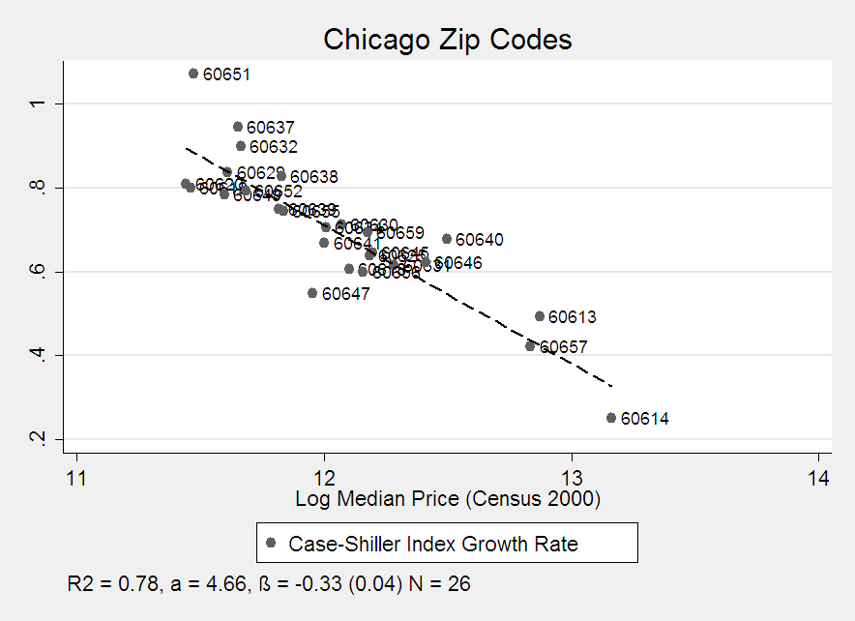
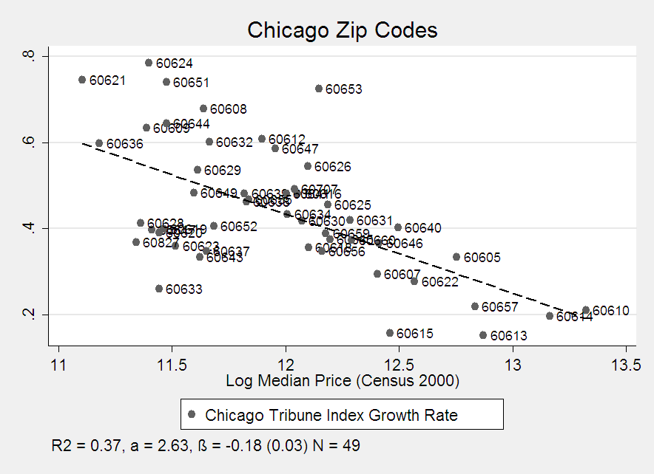
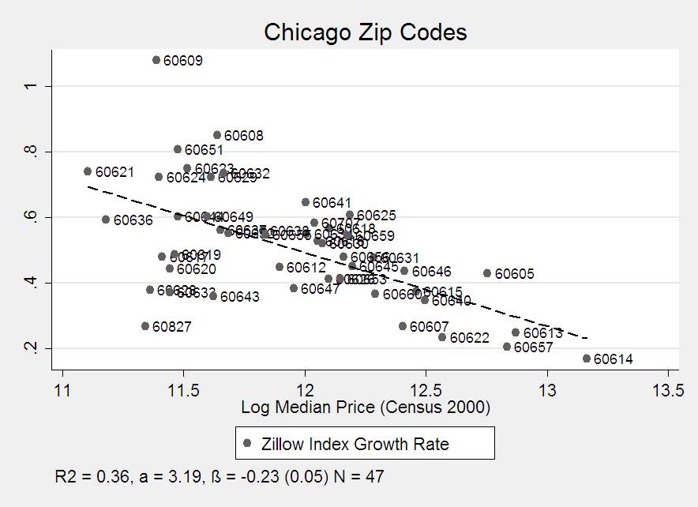
Figure R2: Relationship Between Initial Price Level and Subsequent Housing Price Growth Using the Case-Shiller Data For Different Time Periods
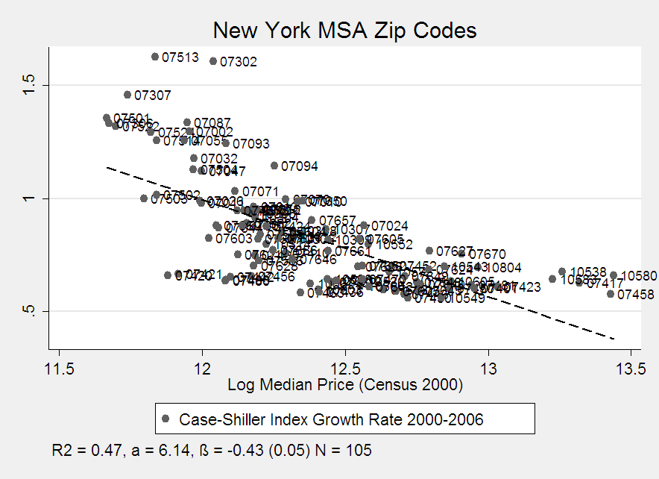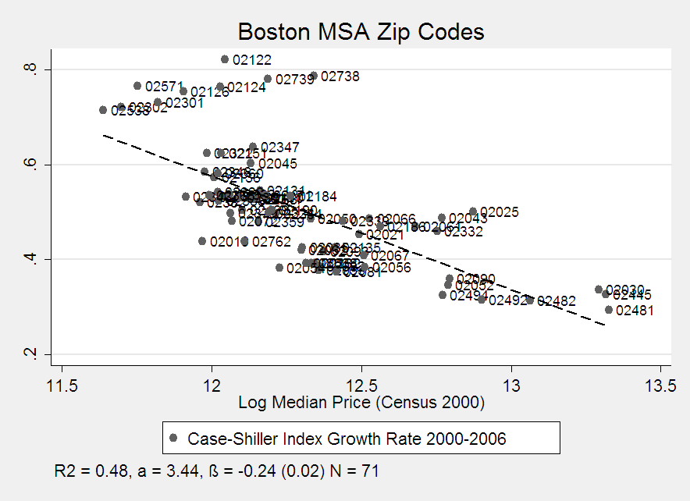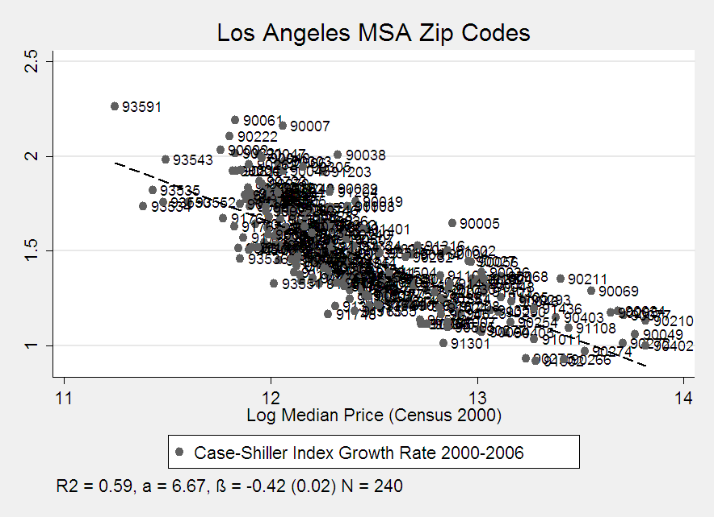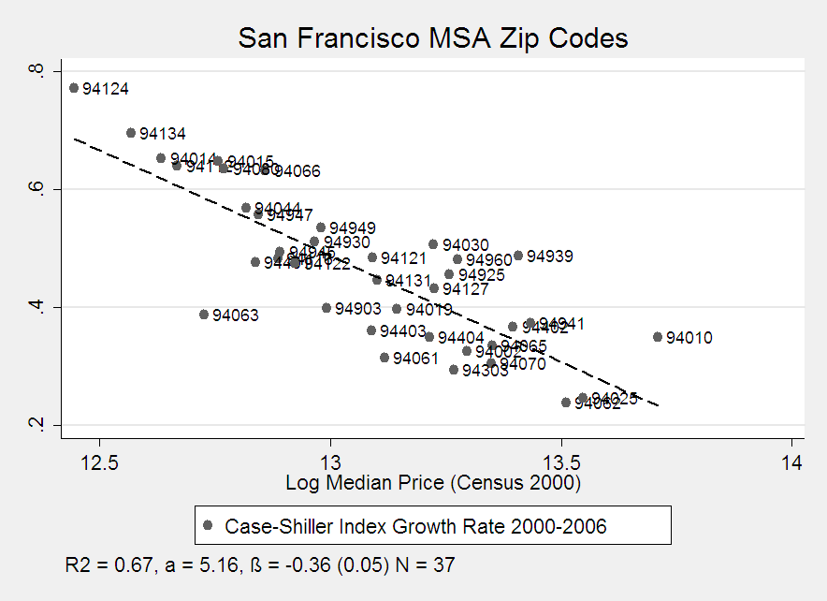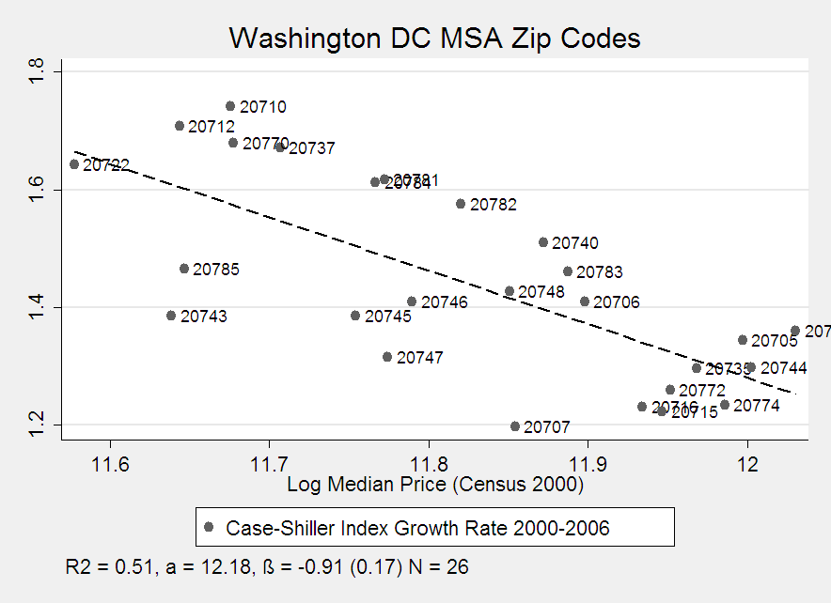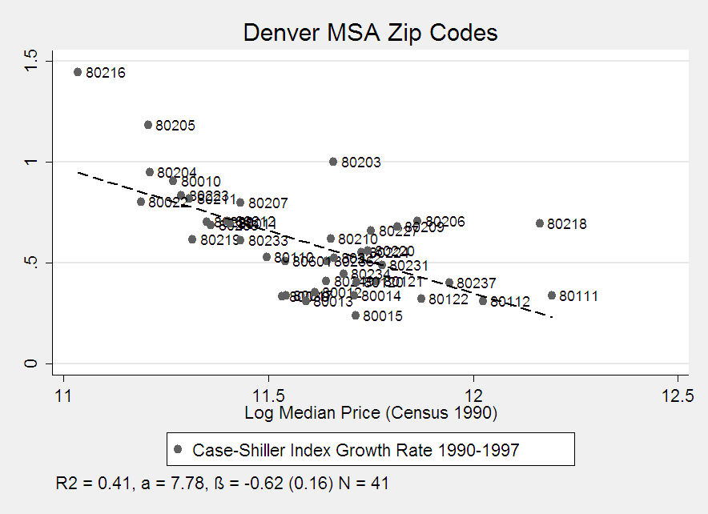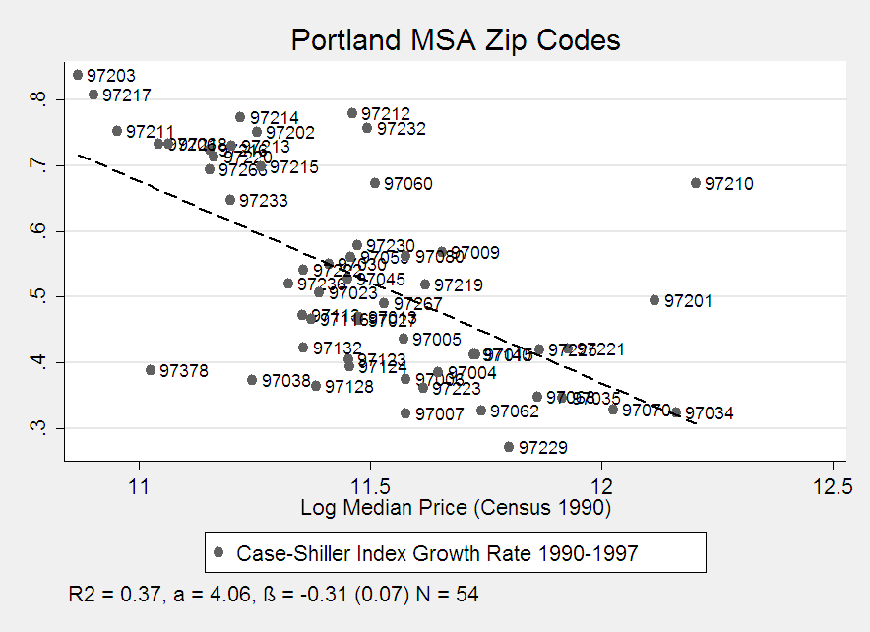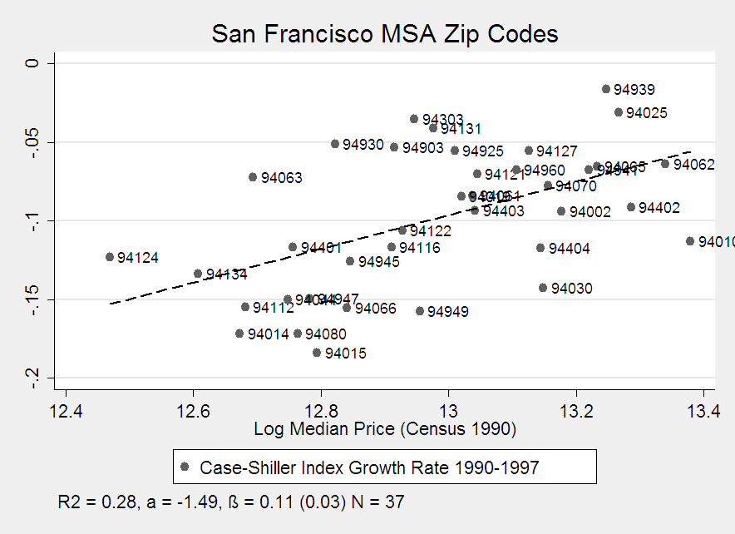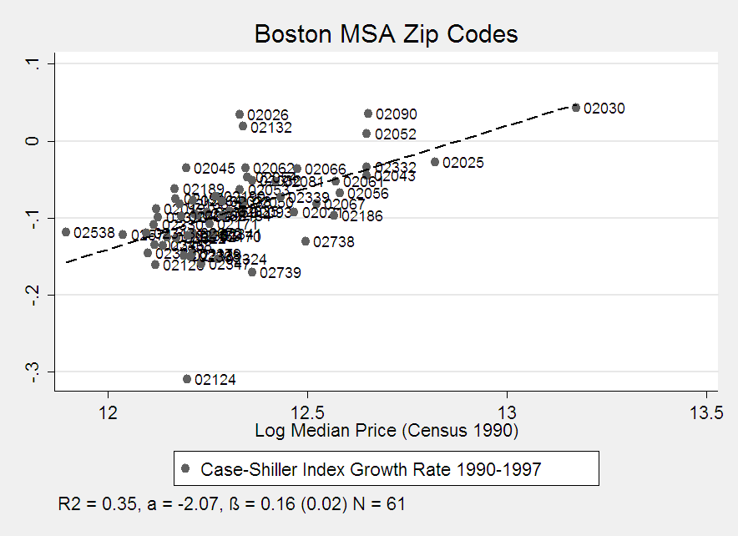

Notes: The figures show in Figures R1 and R2 show the relationship between house prices levels in year t vs. the subsequent house price growth between years t and t+k for different cities/MSAs during different time periods. Each point on the figures is a different zip code. All figures use Case-Shiller data to compute the house price appreciation rates between t and t+k. The initial house price in period t comes from the corresponding U.S. Censuses. These figures just represent the underlying data used to compute the information in Table 3 of the main text. The figures in Figure R3 show similar patterns using the Zillow data. The figures in Figure R4 show similar patterns using data from the Furman Center which makes housing price indices for New York City community areas. See the text for a discussion of this housing price index.
Figure R3: Relationship Between Initial Price Level and Subsequent Housing Price Growth Using the Zillow Data For 2000-2006

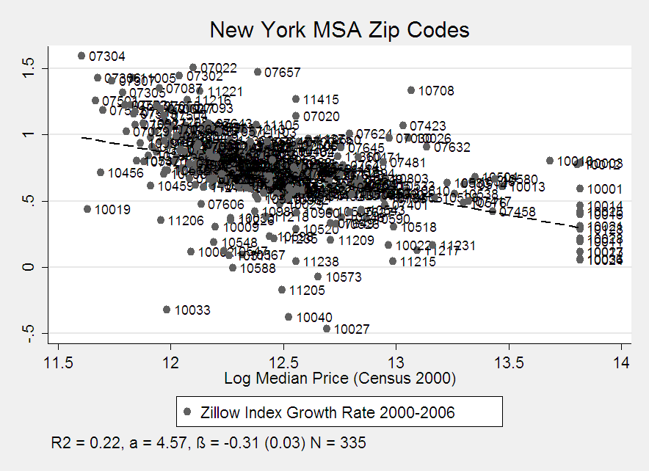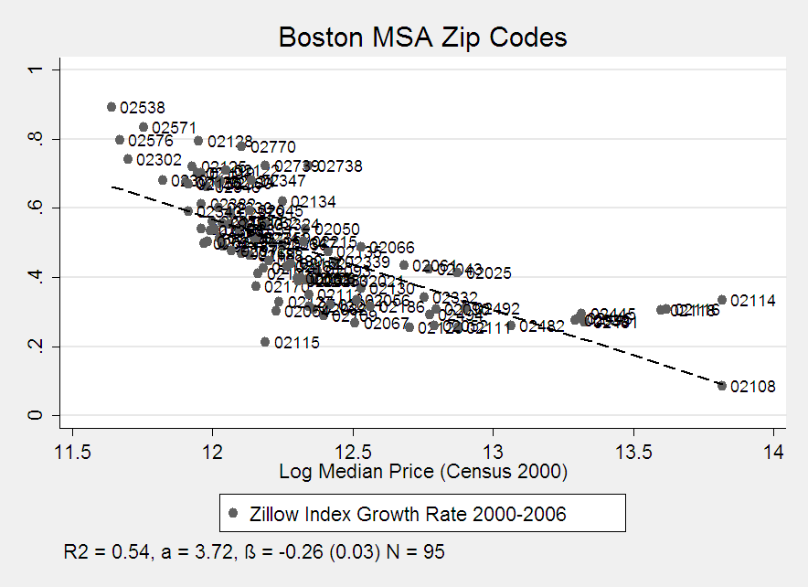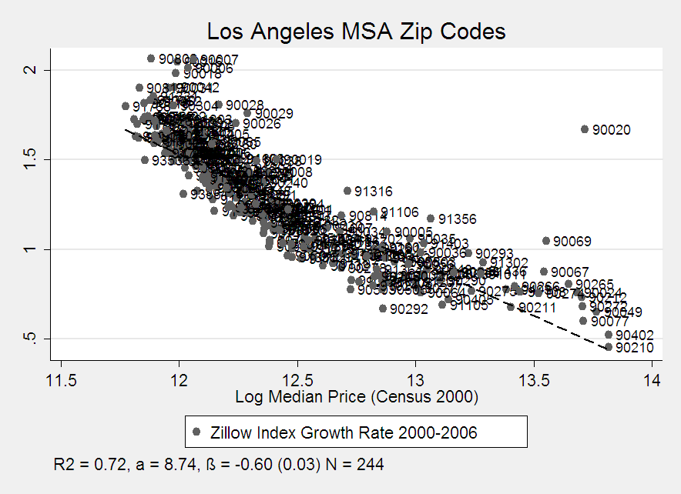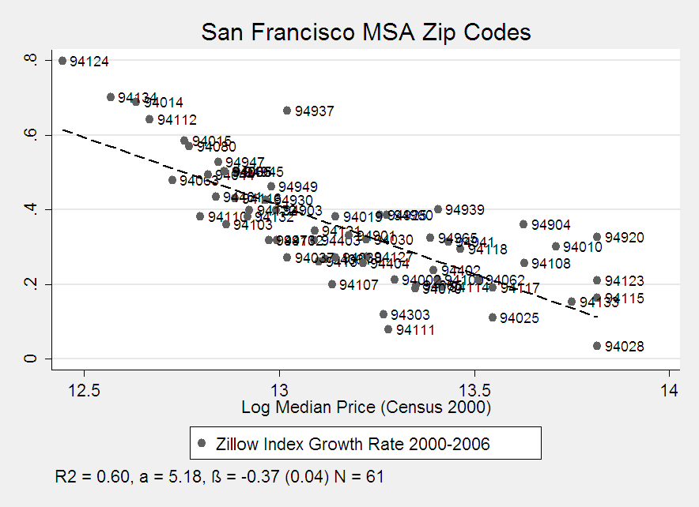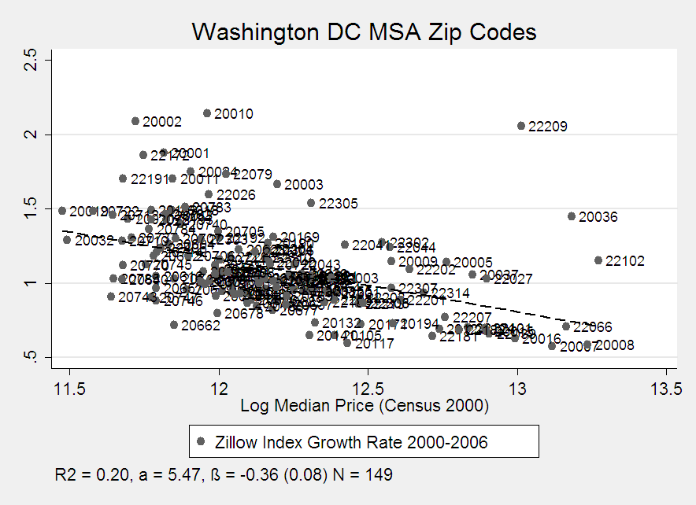
Figure R4: Relationship Between Initial Price Level and Subsequent Housing Price Growth For New York City Using Furman Data

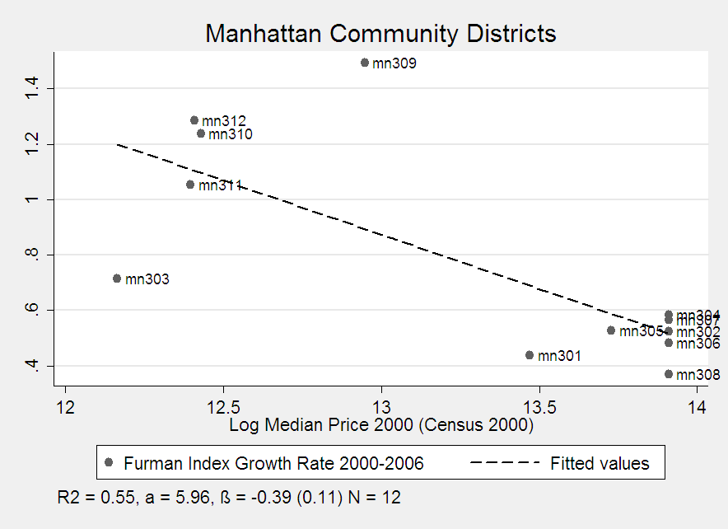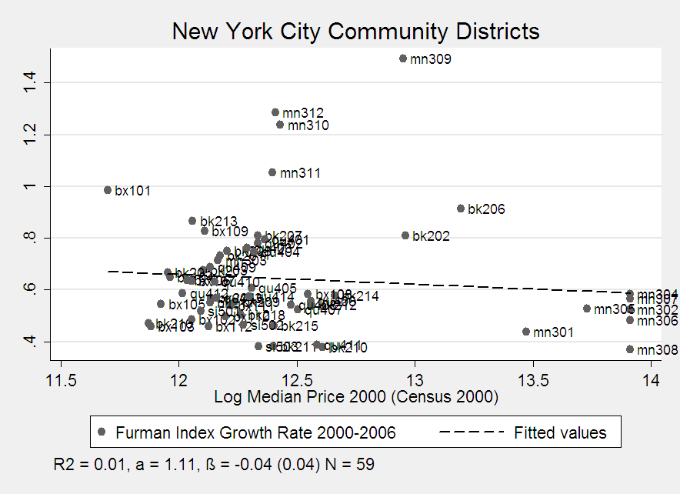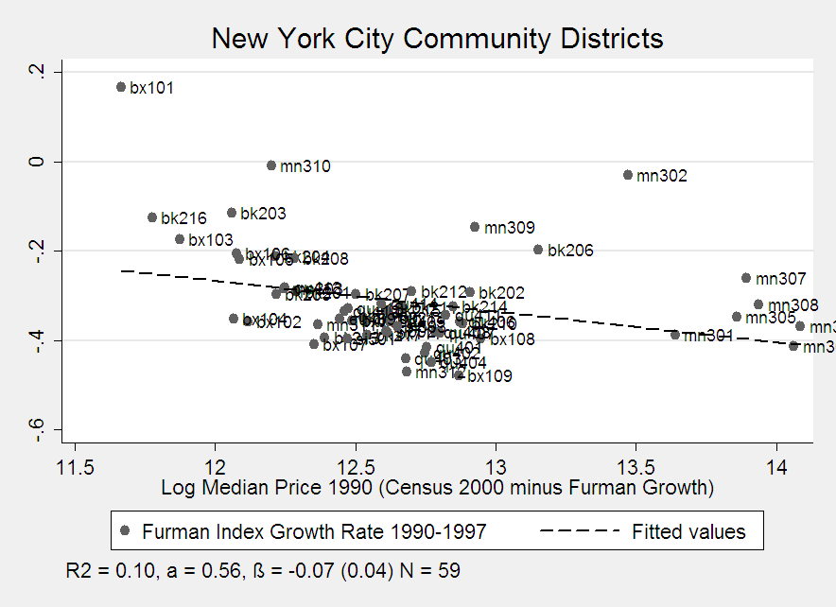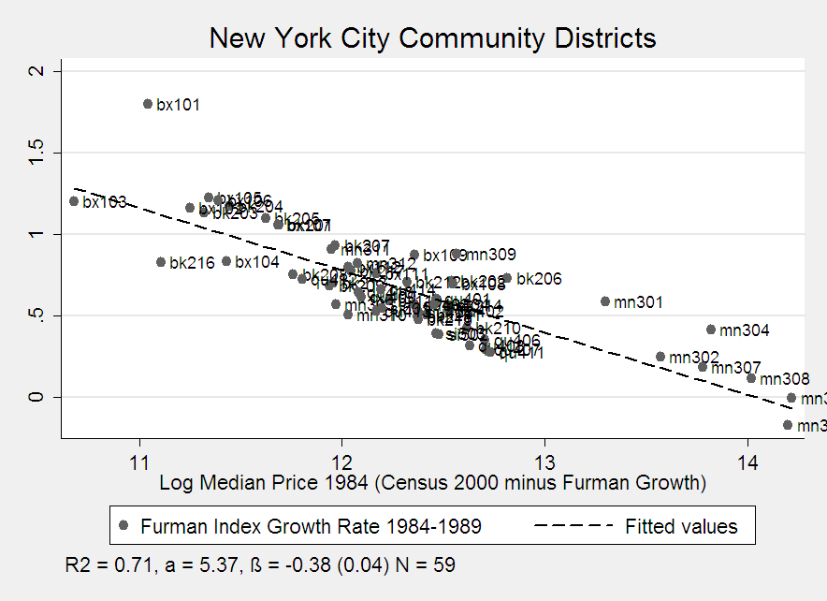
Figure R5a: Relationship Between Differential House Price Growth Between High and Low Priced Neighborhoods and The Level of City Wide Housing Price Growth: 2000-2006

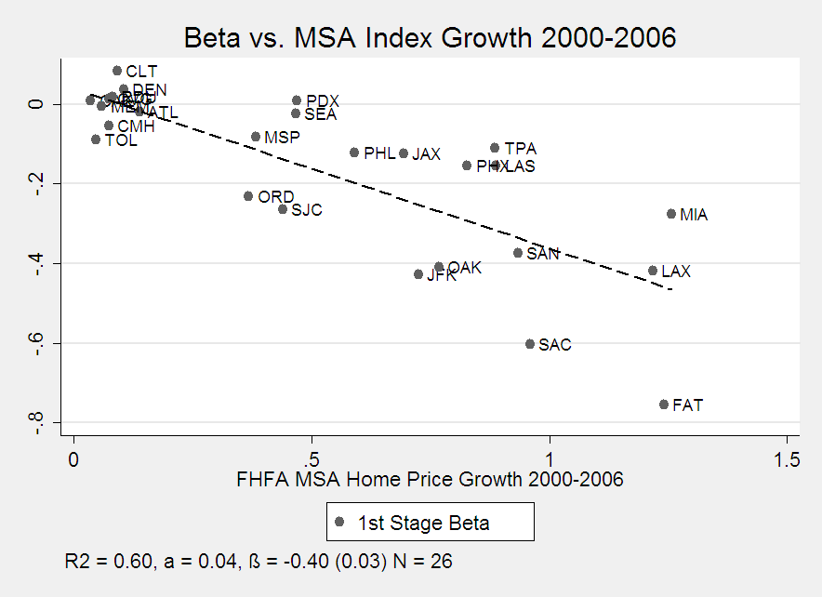

Notes: Figures R5a shows the relationship between house price growth for the metropolitan area as a whole in metropolitan j between 2000 and 2006 (horizontal axis) against the elasticity between initial house price in 2000 and subsequent housing growth between 2000 and 2006 across zip codes within metropolitan j. Each point on the graph is a separate MSA (indicated by airport codes). For example, the LA metro area had a housing price appreciation for roughly 125 percent between 2000 and 2006. Additionally, zip codes within LA where properties were worth $200,000 appreciated roughly a 40 percent lower rate than zip codes within LA where properties were worth $100,000. The house price growth for the MSA as a whole was computed using FHFA data (horizontal axis). The cross zip code within MSA elasticity of housing price growth with respect to the initial housing price level was estimated using Case-Shiller data (vertical axis). The dotted line represents the OLS regression of the different underlying MSA points. The regression line has a slope of -0.40 (standard error = 0.03).

Figure R5b: Relationship Between Differential House Price Growth Between High and Low Priced Neighborhoods and The Level of City Wide Housing Price Growth: 1990-1997

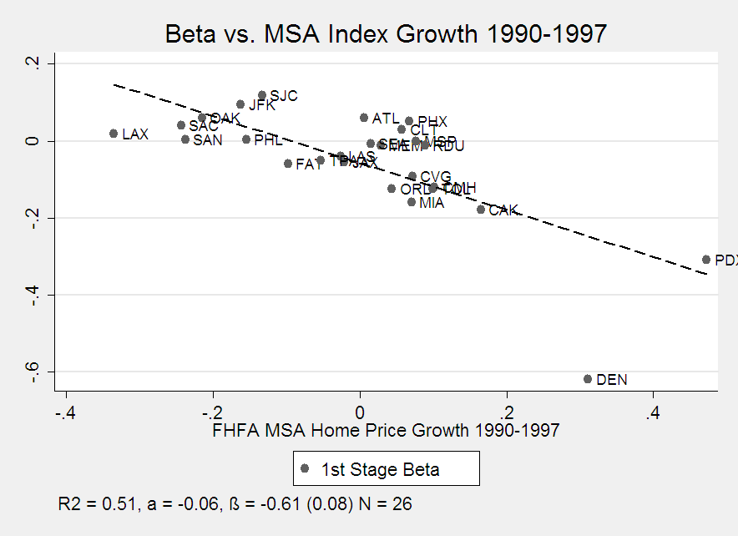

Notes: Figures R5a shows the relationship between house price growth for the metropolitan area as a whole in metropolitan j between 1990 and 1997 (horizontal axis) against the elasticity between initial house price in 1990 and subsequent housing growth between 1990 and 1997 across zip codes within metropolitan j. Each point on the graph is a separate MSA (indicated by airport codes). For example, the Denver metro area had a housing price appreciation for roughly 30 percent between 2000 and 2006. Additionally, zip codes within Denver where properties were worth $200,000 appreciated roughly a 60 percent lower rate than zip codes within Denver where properties were worth $100,000. The house price growth for the MSA as a whole was computed using FHFA data (horizontal axis). The cross zip code within MSA elasticity of housing price growth with respect to the initial housing price level was estimated using Case-Shiller data (vertical axis). The dotted line represents the OLS regression of the different underlying MSA points. The regression line has a slope of -0.61 (standard error = 0.08).

See http://www.zillow.com/wikipages/Real-Estate-Market-Reports-FAQ/ and http://www.zillow.com/wikipages/What-is-a-Zestimate/ for details.
The sample sizes for the entries in the top panel of Table R2 and for the comparable entries in Table 3 are not exact. On occasion, Zillow does not publish a reliable price index for a zip code in the instance where Case Shiller does provide a reliable price index. This is rare. As seen from Table R1, there was only one such zip code within Chicago.

